Procedure to add a Data Module to XERP…

First create a folder for it in the XERP.Web Models folder…
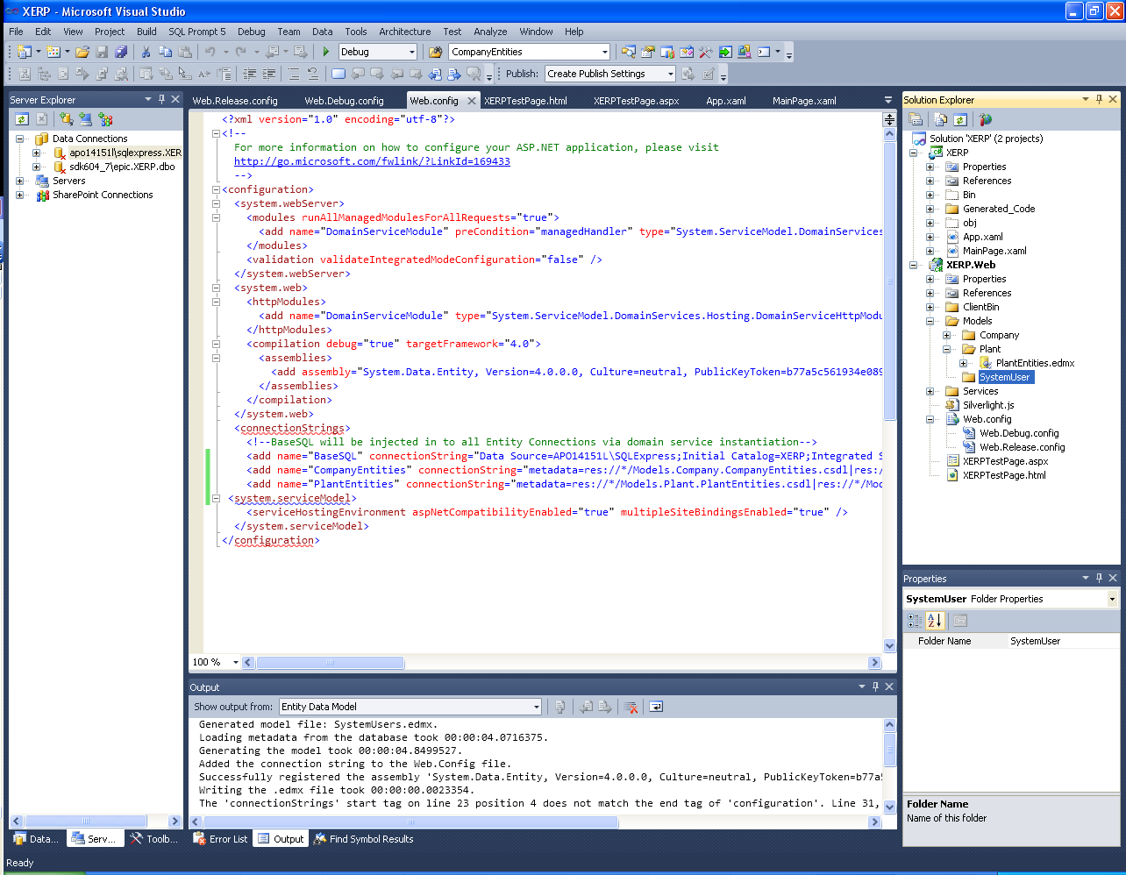

Now right click on the created folder and select Add→NewItem and add an entity as below pay very close attention to naming to maintain consistency in nomenclature.
In this instance we are adding the data module that will support CRUD and functionality for System User Maintenance.
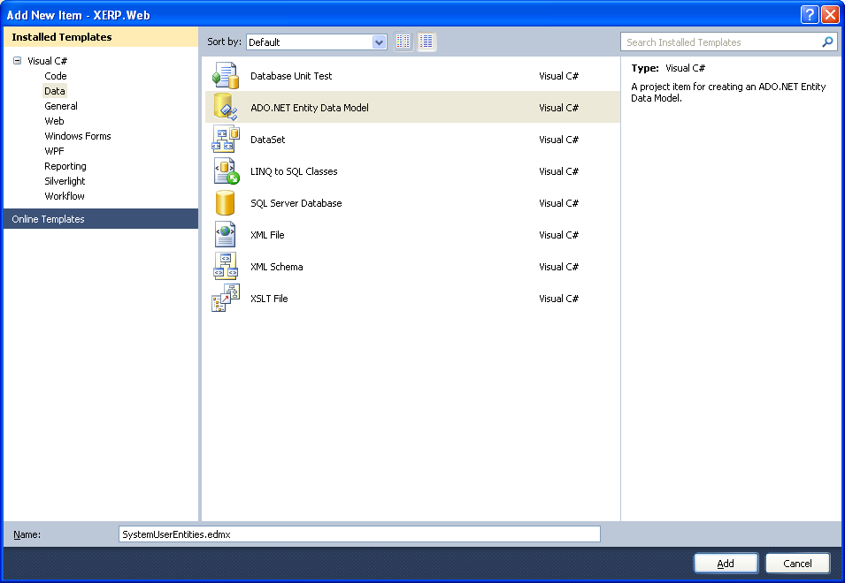

Select Generate from Database.
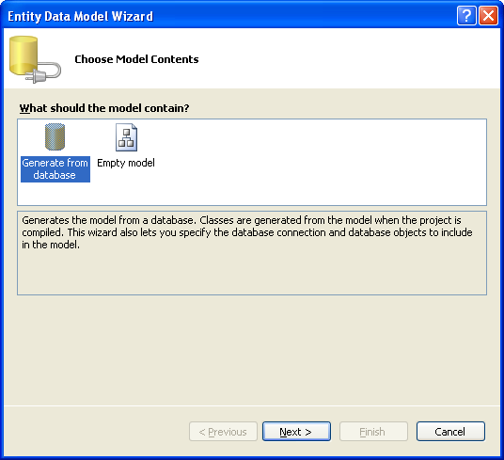

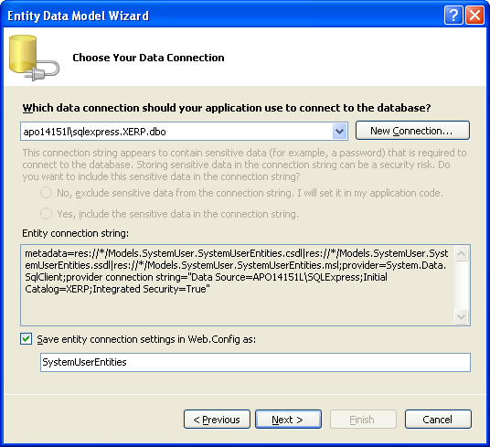
Modify your SQL connection strings appropriately Please note the specificity again in nomenclature for the Connection string ‘SystemUserEntities’
This is important to allow us to override the connection string with our single SQL injection to allot for the same SQL config for multiple Entities…

Now select the tables that are required within this data grouping…
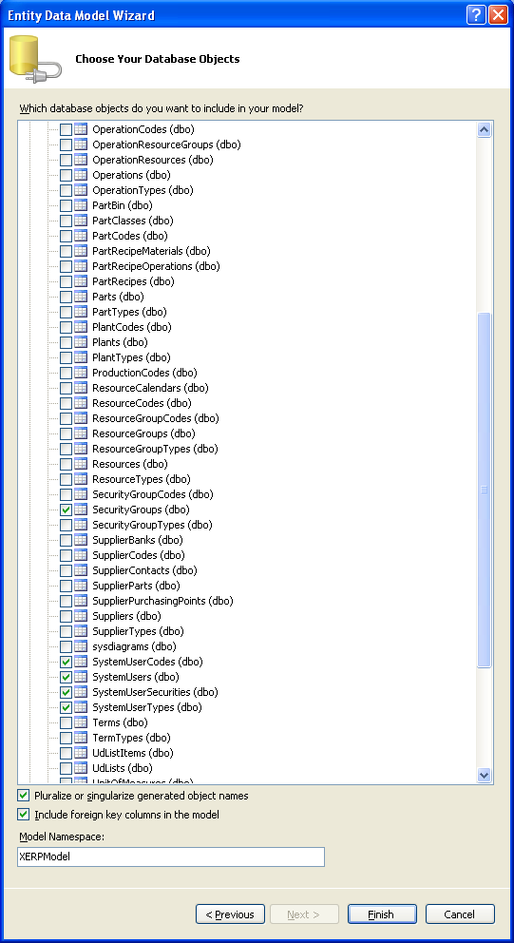

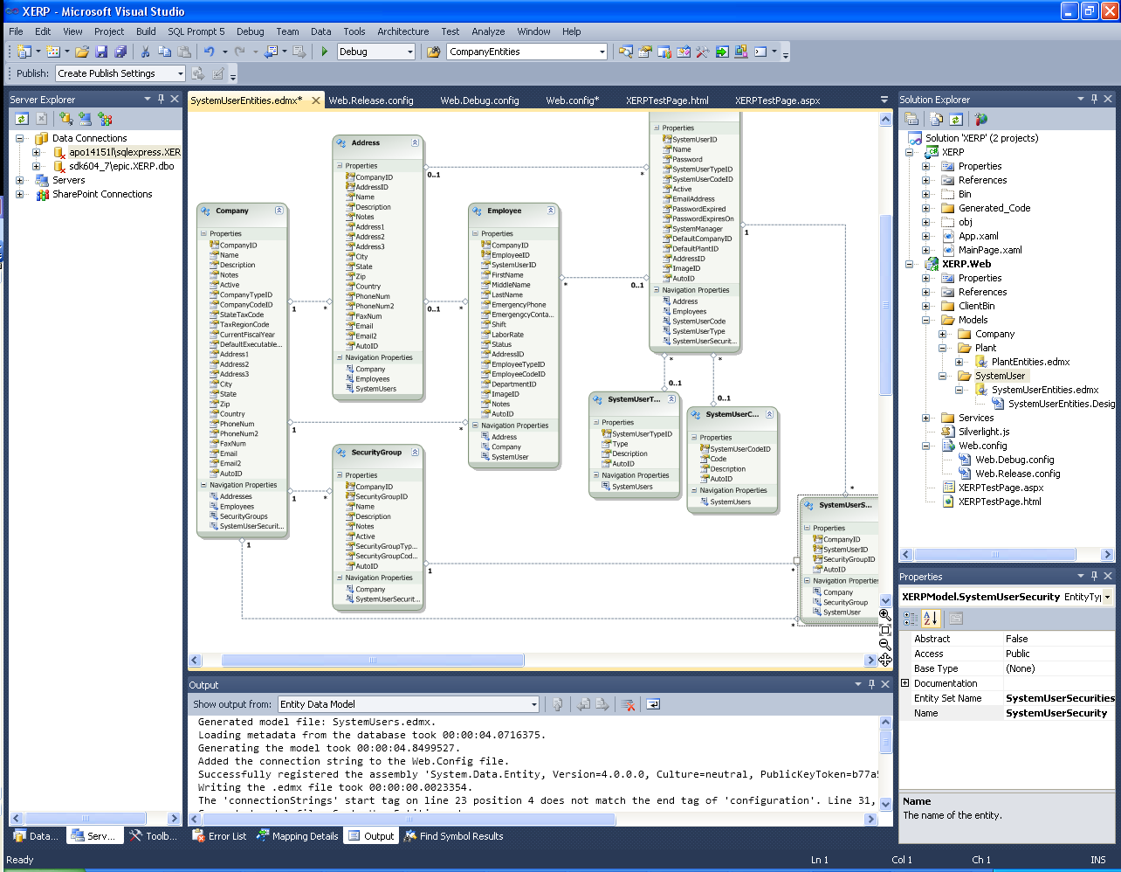
I am left with a very manageable Table set that is pleasing visually and I can very easily pick out the joins at a glance. This is the true power of breaking up your entity in to many small entities…
Note down the road I may find that I need an additional table here or their and in that case I will have to delete the entity and then regen it…

Ok now we have the entity in place we will create the domain service and the extended partial class as the partial class is where we will put our custom methods and any modifications required
To the Canned CRUD code. As with schema changes we will have to blow away the canned code and we don’t want to lose any custom code we built…

In order to do this create a new folder in the XERP.Web Services Folder…
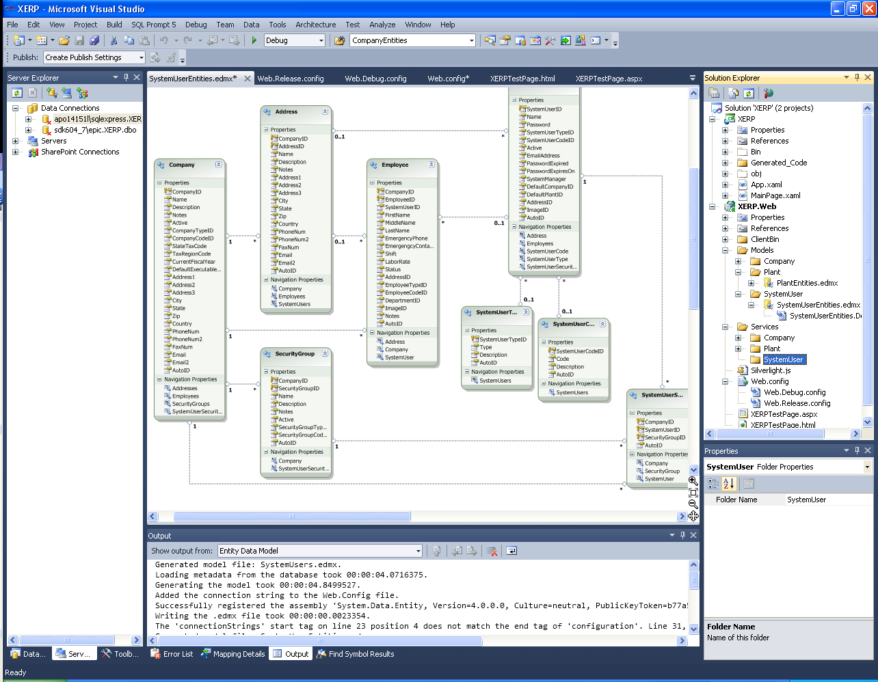

Once the folder is created right click on it select Add → New Item and add a domain service. Note if domain service is not available you will have to Google it and install the template.
Before proceeding do a build as the domain service will not pick up your newly created entity unless you build first…
Again place close attention to naming…
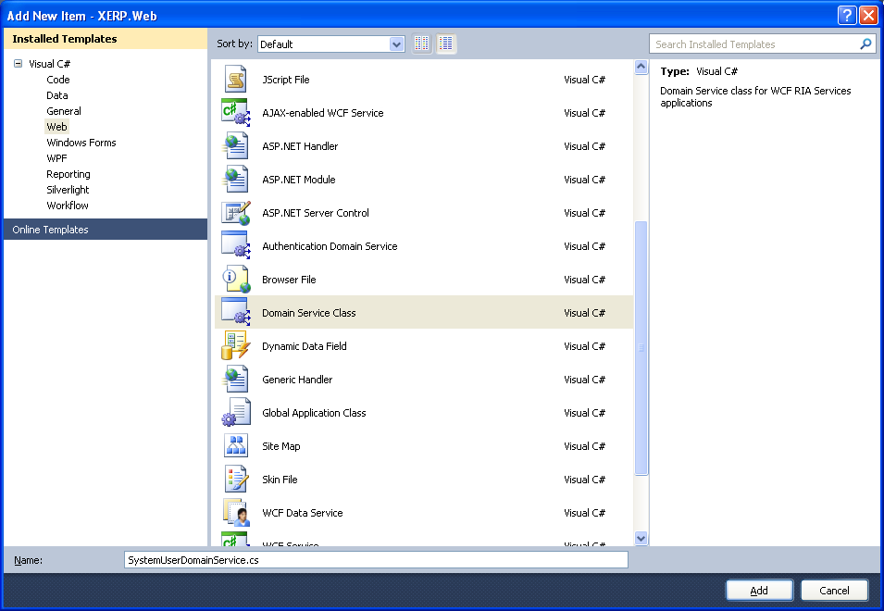

Now select the tables you want in the domain service… Note I have made some table read only while others I have enabled editing…
This is important as to shape the CRUD requirements per table…I am targeting the SystemUser Maintenance and will not want to allow modification to the Company or Security Groups…
It is not huge deal but as some point you may want to have some lower level data triggers and if you allow edit in multiple entities it would require you to do so on multiple entities so it is
Something to think about anyways…
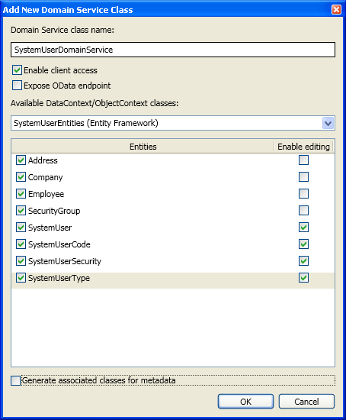
Be sure to uncheck Generate associated classes for metadata as it is not required…
If you forget this step just simple blow away the meta data class generated…

This will be the only modification we make to the canned domain service generated for us…
Add the keyword partial in the class declaration as below this will allow us to generate our partial class…
Also note if you modify any of the canned CRUD which is a very high probability you should cut and paste it to the partial class as to not lose it on schema change
Requirements…
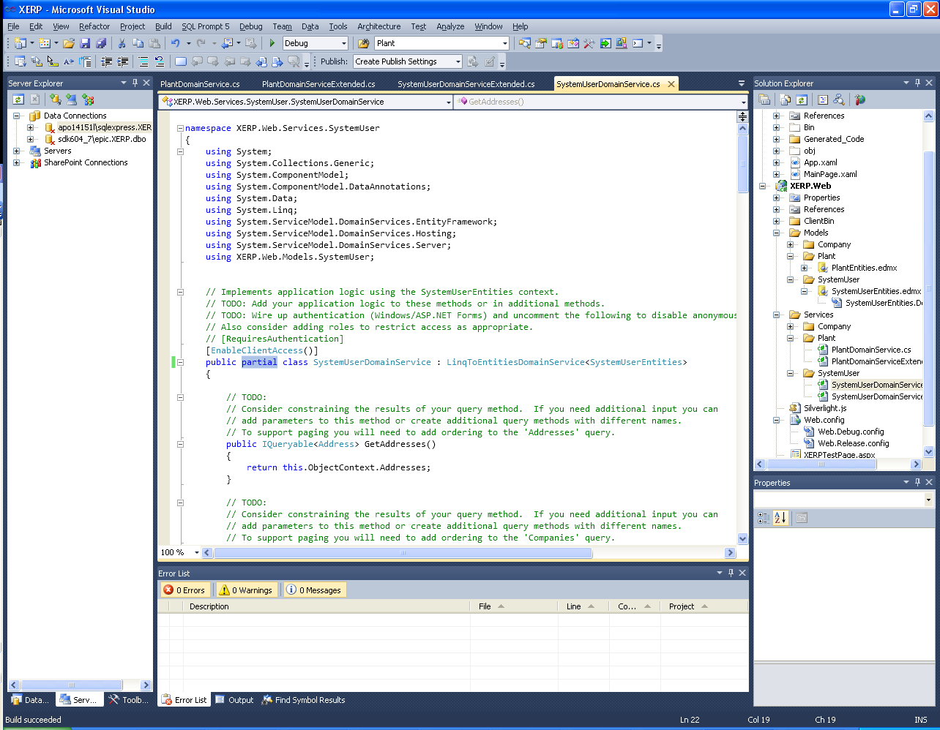

Now we will create the Partial Class. This is important as at any given point if a schema change is required you will have to blow away the domain service class and if you code
Directly in it all your hard work will be lost. So even if you modify the canned crud you should move it to the partial class as to not lose it on regen…

Copy the PlantDomainServiceExtended.cs from the Plant folder and paste it in to the SystemUser folder like so…
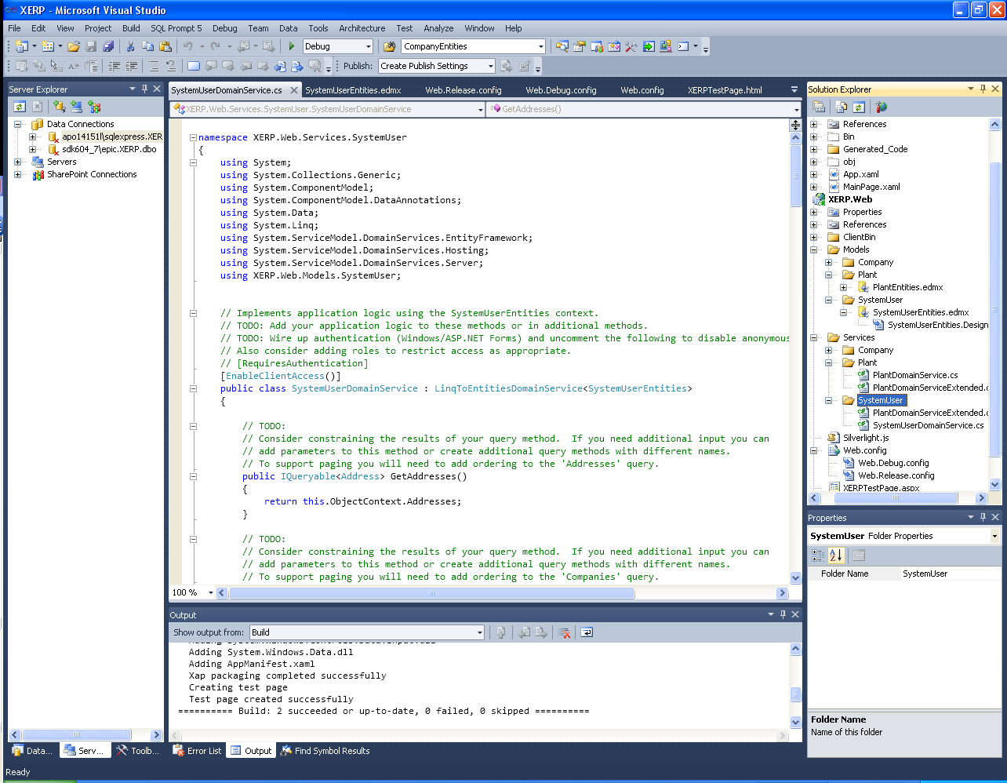

Now rename to SystemUser as below…
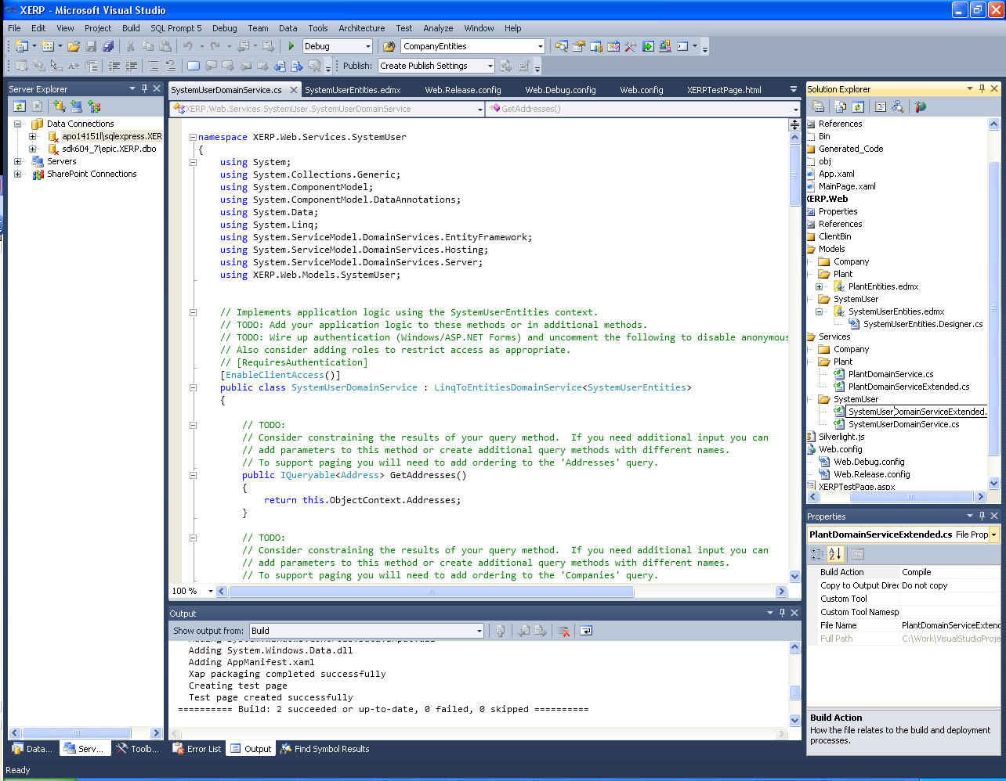

Open it up and lets modify it so it is specific for SystemUser…
The best thing to do is find and replace Plant with SystemUser…
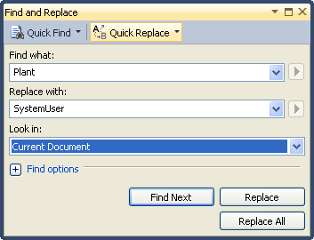

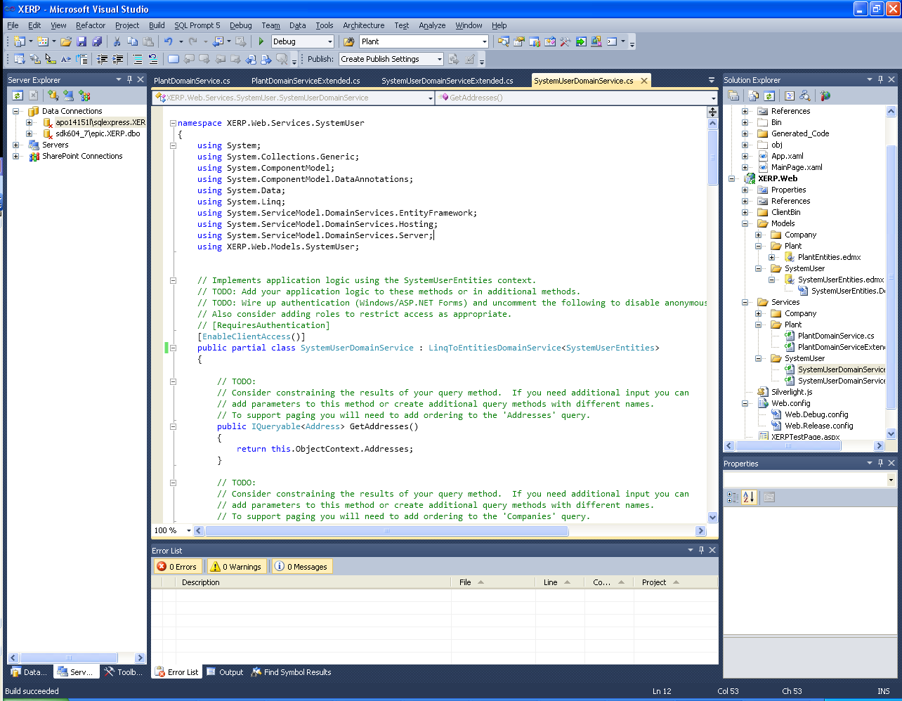
Now build you should have a clean compile and have your Skeloton Domain Built and ready for RIA Services Consuption…
As well your Domain Service Connection String will draw from the BaseSQL Connection properties…

